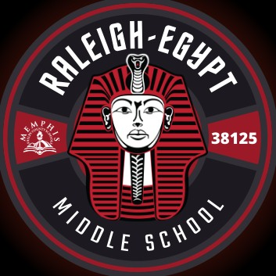Raleigh-Egypt Middle School

UNIFORMS/DRESS CODE

The basic colors for uniform pants, shorts, or skirts are: TAN, KHAKI, NAVY, or BLACK. Uniform shirts must be polo style with a collar and sleeves. The uniform short colors are: WHITE, TRUE RED, GRAY, BLACK, NAVY and GOLD. Shirts—*polo, dress, or turtleneck*—must have a collars and sleeves. NO DENIM material may be worn as uniform clothing.

* **PANTS**:
  + Pants must be tan, khaki, navy, or black.
  + Pants must be straight-legged or boot cut.
  + If belts are worn, they must be fitted and put through belt loops.
  + Pants must fit at the waist and not be oversized or undersized.
  + Baggy pants, sagging pants, tights, or pants made of spandex are prohibited).
  + Denim JEANS of ANY COLOR, pedal pushers, and bell bottoms are not permitted.
  + Walking shorts are permitted for elementary, middle/junior high and high school students. Walking shorts are straight-legged shorts that are at the knee.
  + Full-length pants, cropped pants, cargo pants and straight-legged capri pants are permitted.
* **SKIRTS/JUMPERS**:
  + Skirts/jumpers must be tan, khaki, navy, or black.
  + Skirts/jumpers must be at or below the knee.
  + Skirts/jumpers must be plain/solid material (no see-through or lace).
* **SHIRTS**:
  + Shirts must be plain/solid white, true red, black, navy, or gold without logos.
  + Raleigh Egypt T-Shirts or pullovers may be worn as a uniform shirt daily.
  + Shirts must have a collar and sleeves.
  + Shirts may be polo, dress, or turtleneck.
  + No see-through or lace material is permitted.
  + Shirts must be tucked on the inside unless they are made to be worn over pants or skirts.
  + T-shirts may be worn as undergarments; t-shirt designs/lettering must not be visible.
* **SHOES**:
  + Shoes can have heels no higher than one and one-half inches. This includes wedge heel shoes.
  + Shoes with rollers/wheels are prohibited.
  + Athletic shoes, sandals with straps on the heel, and boots are permitted.
* **UNIFORM OUTERWEAR**:
  + Uniform Outerwear must be without logos. Light jackets, vests, shirts, sweaters, sweat shirts, and cardigans are permitted as items that may be worn over the uniform top.
  + Uniform jackets worn during the day must be white, tan, red, navy, or black.
* **NON-UNIFORM OUTERWEAR**:
  + Heavy coats, heavy jackets, and raincoats are not covered by these regulations.
  + Non-uniform outerwear is not to be worn during the school day unless permitted by the principal for special circumstances.

## Uniform Policy Violation

Teachers will check students for dress code violations. We will use the following disciplinary measures for violations of the School Uniforms and Dress Codes policy.

* Documented Warning
* Call to the parent/guardian
* In-school suspension (ISS)
* Parent/guardian conference
* Overnight suspension
* Home suspension